CHP CAD Simulation Software

1. Overview

The ARDFA researches at Cal Poly State University, in conjunction with CalTrans, California Highway Patrol, and U.C. Irvine, are developing simulation software that will be utilized in the Traffic Management Center training sessions. This software is designed to effectively replicate the CHP CAD software that is currently used in the “live” CalTrans Traffic Management Centers. The software will retain the “look and feel” that currently exists, but will allow scripted simulation incidents to occur.
This document will give a description of each part of the software being developed, including a description of individual and collective software functionality. The following portion of this document will describe how the simulation software will be used during a training session.

2. Simulation Software Components

Cal Poly is designing the simulation software with the Java programming language in order to provide for simple portability to multiple platforms. Java RMI and socket communication are utilized, as will be described in further detail below. There are four main components to the software: CAD Client, CAD Simulator, Simulation Manager, and Paramics system. The first three are being designed by Cal Poly, and the fourth is being designed by UC Irvine. All four components will work together during a simulation, yet all are not necessary, which will be described below. Figure 1 shows the interactions of each element, and the following sections will explain the functionality of each component, and its part in the simulation.

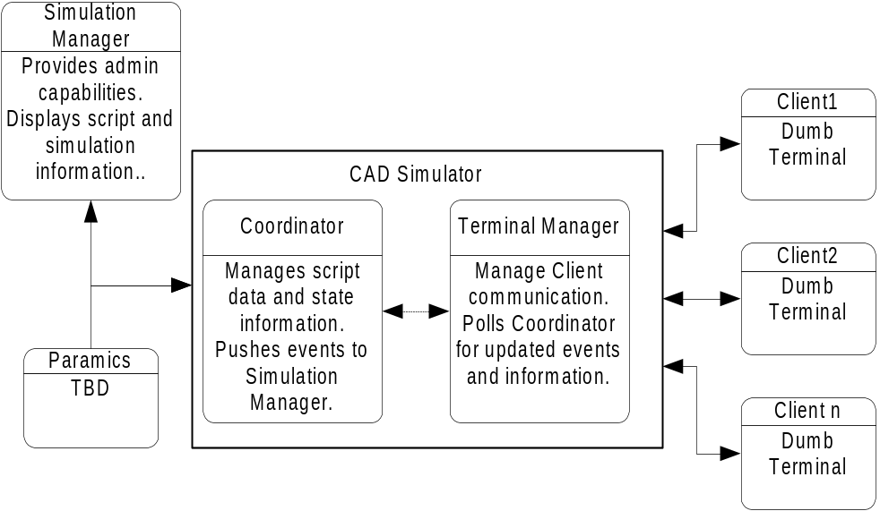
Figure 1 - CAD simulation software components
*Note: In the following description the term “thread” is used. A thread is a portion of a program that performs specific tasks simultaneously and independently of all other threads. By analogy, your body has five senses. Each sense works on its own “thread,” smelling and feeling at the same time, yet independent of each other.

/* or By example, in a “multitasking” environment, each task would be considered a thread. */

2.1 CAD Client
The CAD Client is a dumb terminal that connects to the CAD Manager. When a client is loaded, it connects to the Terminal Manager and creates a TCP socket connection. Data is then streamed between the client and Terminal Manager. Keyboard input on the client is sent to the Terminal Manager, which processes the entry, and then sends the resulting action back to the Client. Multiple clients can connect to the Terminal Manager at once, and each one is handled through a separate thread. Clients may disconnect and reconnect at any time throughout a simulation, and there will be no loss of data.
The Client is designed to closely replicate the “real” CAD software that is utilized by Caltrans and the CHP. A detailed description of CAD functionality and looks will not be included here. (For information on the CHP CAD, reference the ??) Listed below are the CAD commands and resulting screens that are implemented in the CAD Client software:

- IB – Incident Board Screen
- SA – Incident Summary Sceren
- II – Incident Inquiry Screen
- UI – Updates an incident
- TO – Send a routed CAD message to another CAD terminal
- ON – Login Screen
- LK – Lock Keyboard

For additional information on these CAD commands and the additional function keys that are implemented, view the Javadoc for the CADScreens class. (link). All relevant classes to the CHP client are contained within the (real name) calpoly.edu.CHPCAD.client package. View Javadoc documentation for more information.

2.2 CAD Simulator
The CAD Simulator is the central unit of the simulations. This component controls all communication with the CAD Clients, the Simulation Manager, and the Paramics system. There are two internal elements to the CAD Simulator, the Terminal Manager and the Coordinator. Each of these is explained below.

2.2.a – Terminal Manager
The Terminal Manager handles all communication with the CAD Clients. When a client connects to the Terminal Manager, a new thread is spun with a TCP socket connection to the connecting client. All input is then received by the Terminal Manager, processed and returned. The client input will be a character (letter, number, etc) or a CAD function. Received characters are appended to the command line and returned to the client for display. Received functions are processed and then the resulting CAD screen or data is returned to the client.
As explained, when a CAD Client connects, the Terminal Manager spins off a thread to handle all communication. While this thread is active, it polls the coordinator for triggered events, received routed messages, and other CAD update information. When new information is received, it is sent to the CAD client for the user to view. When the user executes a CAD command that inserts data into the simulation, this data is passed to the coordinator. The coordinator’s functionality is explained below.

?? All relevant classes to the CHP client are contained within the (real name) calpoly.edu.CHPCAD.CADSimulator package. View Javadoc documentation for more information.

2.2.b – Coordinator
The Coordinator is responsible for managing the simulation information. The Terminal Manager contacts the coordinator for all CAD data that is displayed to the users.

The following CAD simulation data is managed by the coordinator:

- List of incidents created from script file
- CAD simulation state information
- List of triggered incidents and events
- CAD Incident Inquiry Screen information
- CAD Incident Summary Screen information
- CAD Incident Board Screen messages
- CAD Routed Messages

A simulation script is loaded into the coordinator when it is first run as a command line argument, or through the Simulation Manager, explained in section 2.3. A simulation script contains a list of incidents and each incident has an associated list of events. A sample incident and a format description are shown in figure 2.

Figure 2- Sample incident and format description
Example:
First Incident~
0:00:05~
0:00:00~EI.L/1179 NB 405 JSO MACARTHUR BLVD.T/1179.P/4.C/I.B/14-1 .D/14-13 ENRT NB 405 JEFFERY ROAD ~incident1.wav~4~

Format:
Incident Name~
Incident Start Time~
Event Start Time ~ Event Info ~ Audio File ~ Audio File Delay Time

Note: Event Start Time is relative to Incident Start Time

After a simulation has started, the Coordinator keeps track of how long the simulation has been running. The coordinator triggers each incident and event at the time specified in the script file. This information is then polled by the Terminal Manager and pushed to the Simulation Manager.
The Simulation Manager connects to the coordinator through the Java Remote Method Invocation(RMI). When the Simulation Manager is loaded, it registers itself with the coordinator. It was determined that having the Simulation Manager poll the coordinator for updated information would be inefficient in a distributed computing realm. In addition, RMI was chosen instead of sockets in order to eliminate a convoluted communications protocol between applications. RMI allows the Simulation Manager to remotely call methods within the coordinator and for the coordinator to call methods within the Simulation Manager. Thus, when an incident in the simulation occurs, the Coordinator can send this information directly to the Simulation Manager for display.
Connection from the Simulation Manager is not necessary for the coordinator to run a simulation. The Simulation Manager allows a way for the user to view and monitor the status of the simulation.

?? All relevant classes to the CHP client are contained within the (real name) calpoly.edu.CHPCAD.CADSimulator package. View Javadoc documentation for more information.

2.3 Simulation Manager
The Simulation Manager allows a user to view and manage a current simulation. The Simulation Manager may be run from any remote system, and it connects to the coordinator through Java RMI communication, as explained in section 2.2.b. When the Simulation Manager is loaded, it contacts the coordinator and loads any of the current simulation information. This allows the Simulation Manager to be loaded after a simulation has already begun. The following simulation information is displayed to the user:

- Current Simulation Time and Status
- Loaded Script name (if loaded)
- Incidents in loaded script (if loaded)
- Incident Events that have already occurred in the simulation.

The Simulation Manager also provides administrative functions. The primary functions are to load a script into the coordinator and to start the simulation. The user may choose to run the simulation in three modes. In each mode, the simulation will run as it occurs in the simulation script, with the additional functions listed below.

- “Auto Mode” – The user may increase or decrease the speed of the simulation.
- “Manual Mode” – The user may trigger an existing incident prior to its scheduled time. The user may also load additional incidents not found in the original script file.
- “Paramics Mode” - TBD

The Simulation Manager also provides a CHP Client for the administrative user to use. This client screen is on the second tab in the Simulation Manager screen. The client connects to the Terminal Manager and acts in the same manner as other remote CHP Clients.

?? All relevant classes to the CHP client are contained within the (real name) calpoly.edu.CHPCAD.SimulationManager package. View Javadoc documentation for more information. Also see the CAD Software Requirements Document: http://waldorf.calpoly.edu/~mcechini/ardfa/chpcad/CHPCADRequirements.html

2.4 Paramics
It is yet to be determined how paramics will interact with the CAD simulation software. Possible interactions are:
- Reactionary – The CAD Software would notify Paramics Assessment: This does not seem that it would coincide with the design of Paramics. The incident information would reach the trainees before the Paramics and NET systems could adequately display the affects of the incident. This would not be a realistic simulation. Paramics needs to push the CAD Simulator.
- Micromanagement – The Paramics system would notify the CAD Simulator of every incident and every event found in the script. Assessment: This deep level of triggering is overkill, and does not follow in line with the current design. A more abstract level of triggering is needed.
- Macromanagement – The Paramics system would notify the CAD Simulation when each incident occurred, and the CAD system would then trigger each incident’s events according to the script information, independent of Paramics. Assessment: It seems as though this is the most logical choice. The Paramics system would begin to display the incident’s affects on traffic, and then the CAD Simulator would be notified, and the incident would begin. The Paramics system has knowledge of the CAD events and could coincide its display with the script. This would also allow for on the fly incident triggering. The CAD Simulator could notify Paramics that a manual trigger is wanted, and then Paramics would begin to respond, and when ready it would contact the CAD Simulator to begin the incident.

3. Running a Simulation

3.1 Visual Overview of System Components

The following graphic shows how each component of the simulation software will interact. The Simulation Manager and CAD Simulator are separate applications, but may be run on the same physical machine. The CAD Clients must all be run on separate machines. Paramics is also a separate physical entity.

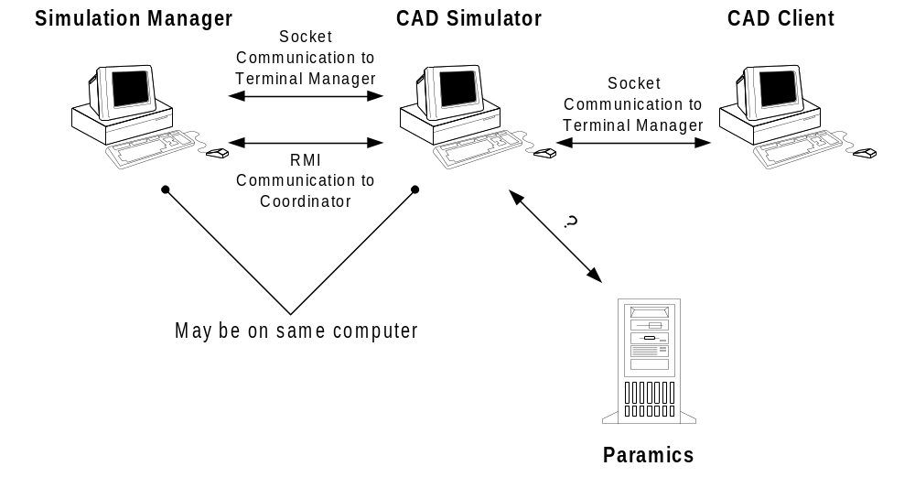
Figure 3 - CAD software components .

3.2 CAD Simulation Steps

The sequential list below shows the steps that are taken to run a CAD Simulation.

- Start CAD Simulator – The CAD Simulator must be started first. All other components will connect to this application. The simulation script may be loaded when this program is loaded. If it is, the simulation will immediately begin.
- Start Simulation Manager – The Simulation Manager must be started if the script was not loaded when the CAD Simulation application was loaded. The Simulation Manager may be loaded at any time after the CAD Simulator has started.
- Start CAD Clients – The CAD Clients may be loaded at any time after the CAD Simulator is started. The Simulation Manager does not need to be loaded for a Client to be started.

Load Paramics??
- Load Script – If a script was not loaded when the CAD Simulator was started, load a script file using the Simulation Manager.
- Start Simulation - Whenever the simulation is ready to begin, start the simulation from the Simulation Manager.
- Manage through Simulation Manager – During the simulation, the Simulation Manager will display the triggered incidents and events. The administrative users may also manage the simulation as desired.

